SMG Resources, LLC

Memorandum

To: Usman Khalid

From: Susan Gregory

Date: 23 September 2015

Subject: Choose Life Now Promo Pages

I am in the process of creating a series of short video messages to use as a layered, multi-day promotion for Choose Life Now. The delivery is simple and I believe the page can be created once and then copied and updated as the videos are added. Site Model

The URL is:
http://choose-life-now.com

http://choose-life-now.com/wp-admin

User: u.k.se.it.mm@mezzimarketing.com

PW: Richard777

Here is a sample that fits what I want (see next page for site image):

First video page: http://fletchermethod.com/video-one-u20/?inf_contact_key=17b21235a989dbdea659a73bd28c8e9f54f434d95c2d7fece8b070d3a3fd6b02

Fourth video page (with offer): http://fletchermethod.com/video-four-u20mps/?inf_contact_key=a9a72164f2118af8f71ace210c95e7767b23cba636d6cad945f547a40d0074de

NOTE: I plan to work on updating the site to Divi. I also just installed OP2 plugin so you can create these pages. If I switch the theme, will it affect the pages you create?

Also, I will create some placeholders for the video images then replace them as I get the content done. Please let me know what I need to do. I can get around the pages okay, so I am okay with you just using placeholder text and images for me to update.
# # # more on next page # # #
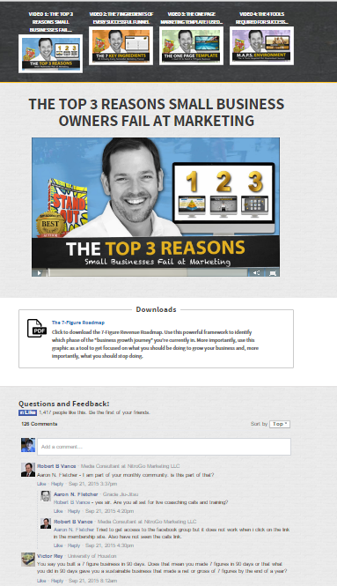
I like the looks of this site. It seems straight forward. I want to use them model for the Choose Life Now promo. Then if it produces well, I will use it for some of the other products I have now and some I will be creating in the coming weeks.

Please note the various elements on the page:

- Banner at top with the four video clickable images (I’m sure you get this, but to be complete – day one the only video the viewer can click is #1. Day two both #1 & #2, etc).
- Content area with headline and video
- Download for PDF file.
- Social proof using Facebook feed.

I have a series of emails that I will send over 7-10 days, which will include the links to the pages. No login or drip functions required.

I hope I’ve made all this clear enough!

Thanks!

